SP3D PIPING DATA STRUCTURES

PIPELINE
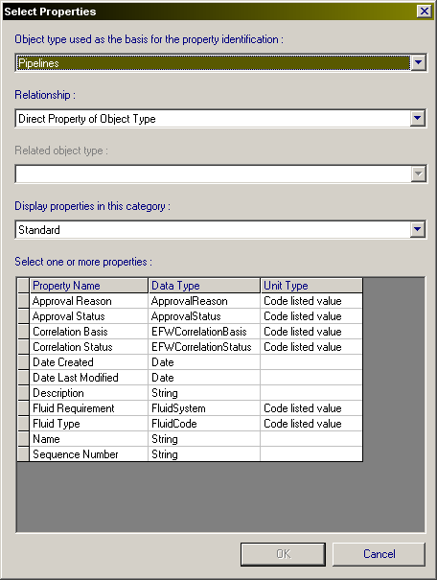
The “Name” attribute can be typed in by user or made up by rule using an automatic concatenation of attributes such as fluid type (fluid code) and sequence number. An area or unit name attribute could be added.

PIPERUN/standard attributes
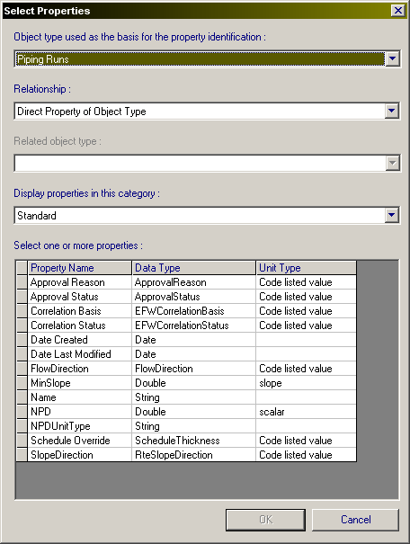
The “Name” attribute can be manually typed by a designer or automatically generated by a rule and the name generator. The rule concatenates any of these attributes and the name generator server creates a unique sequence number. This number is unique regardless of the number of users working in the same area at the same time, since it’s generated from a central location. If manually typed in, then Name uniqueness across piperuns is not checked by SP3D. Additional property categories for piperuns follow.

PIPERUN/responsibility
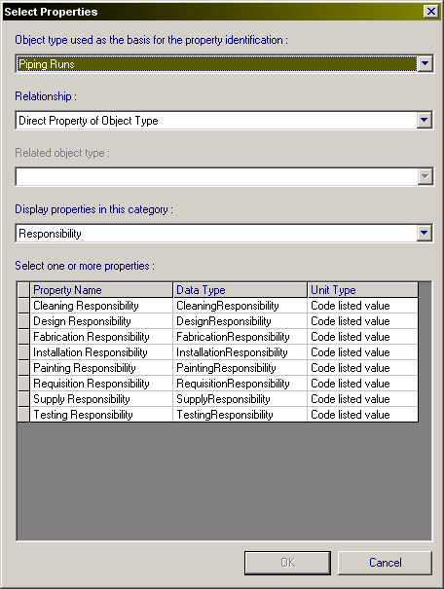

PIPERUN/testing
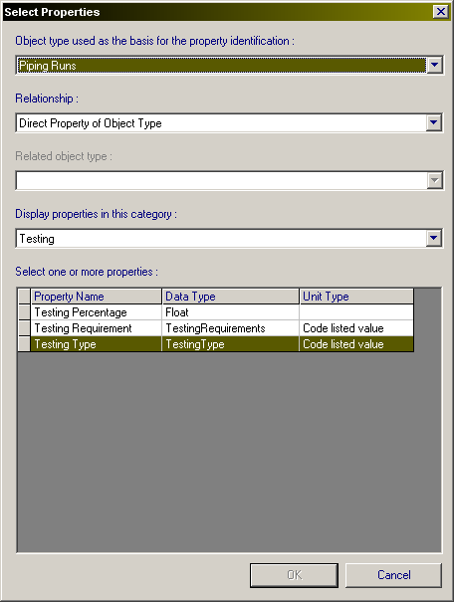

PIPERUNS/surface treatment and coating
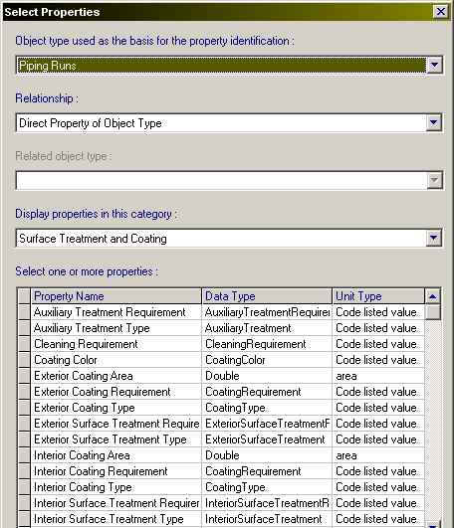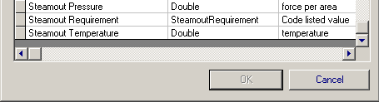

PIPERUN/temp & pressure
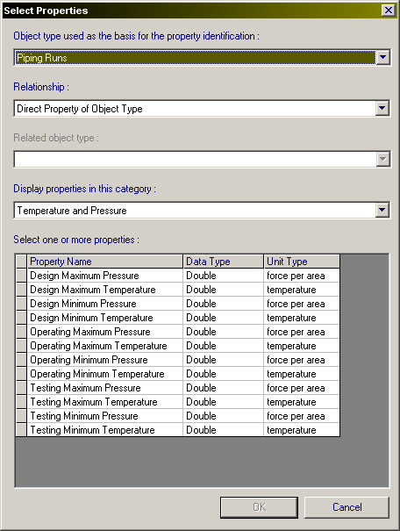

PIPERUN/insulation & tracing
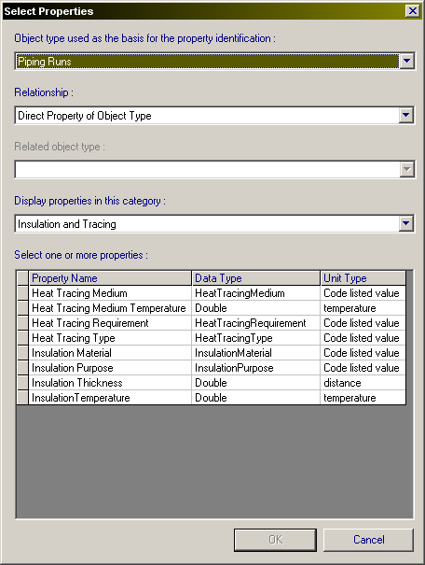

WORK BREAKDOWN STRUCTURE (WBS)/WBS project
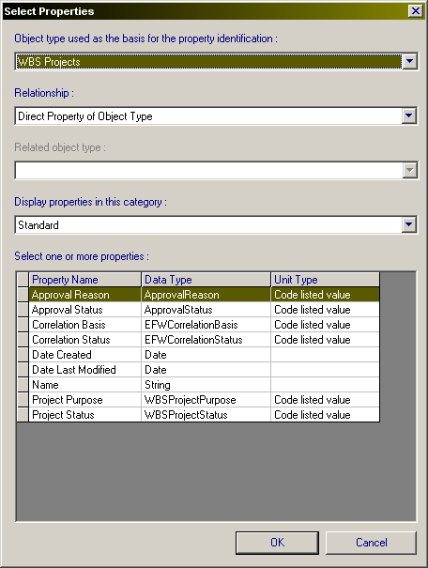
The WBS project will hold WBS packages which are useful for grouping items for reporting, drawing extraction, graphic display, etc.

WBS/WBS items
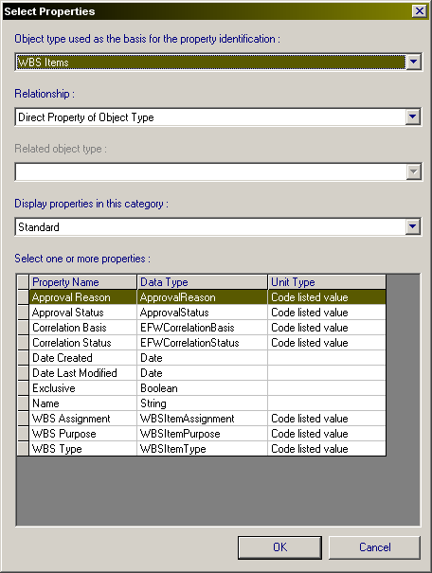
WBS items serve for packaging or grouping together related or unrelated items for future manipulations. The most typical example is isometric drawings extraction. Integraph does not provide much flexibility in choosing a line attribute or attributes to extract isos by. They can only be extracted by pipeline, piperun, spool or WBS (there are of course stress isos). Ingr encourages the use of WBS packaging for batch iso extraction type of function. The equivalent of bulkloading lines for batch iso extraction is the loading of lines to WBS package (interface shown below). This was used for Cliffside project with SP3D V7. Somewhat problematic at times but eventually got all iso drawings out. It would expedite extractions if we could skip this WBS packaging step, but there aren’t many options as mentioned above.
